

|  |
| --- |
| **Halo Salt Therapy** |
|  |
| **March 26**  **Submitted By:**  **Submitted to:** |



# EXECUTIVE SUMMARY

Do you need to get more stress releasing and friendly environment in your daily life from your busy schedule while enjoying great service? If you do agree with us, then Halo salt Therapy is the answer. Our salt therapy provides the best therapy in the world which relaxes the human body and mind of the person. Although it could improvise the lung and improve it to the significance level utmost.

Our therapy could help the patient to alleviate some disease respiratory problems, Asthma, Allergies, emphysema, and lung diseases. We are well organized, well-skilled, toll with a high level of experience of the world-class level. Our way is the systematic way of individuals, families and the business environment as well. We can remove the pain, lift the headache, unfasten the problems that you are looking for. We ensure the service in replacement of the medical industry to deliver the salt room services. We under the oath can make sure all the laws and regulations we follow the policies rules and regulations too. Needless to say, our customers will surely get pleasure from our services and get healed from their ailment they look at our proposing services. What is new if we are claiming to be the most unique services. Here it is the magic world while getting therapy. For example, the application of dry sodium chloride aerosol is the basic nature of Halo salt therapy, use the Himalayan salt in their treatment. Although, Himalayan salt contains a high concentration of minerals that are good for health.

# **BUSINESS OPPORTUNITY**

## MARKET GAP

“It is not about you. It is about serving target customers and their needs and resolving their pain while therapy!” - John Mullins (2018)

Community concern about health attracts the changes in the therapy of people and brings the new healthy trends that deliver the medical practices that they are now well but they, in reality, are not—traditional healthcare now find the convenience to refer their own patient to somebody else. In the case, healthcare practitioner uses to send their patient to other clinic and doctor who can make their pain go. What could be the therapy if they need someone else to do their job? which leaves the big question mark.

It helps to reduce their mental level, giving them the chance to restart their energy level again from our services, help to boost their creativity level when they get therapy. We are presenting the natural holistic, drug-free salt for better breathing, softer skin, beautiful sleep, physical fitness, and mental relaxation as well. Halo salt therapy for the people who always looking for health service and a great amount of satisfaction.

Indeed, people are looking for physical fitness after the alt therapy in the market they do waste their time by looking at the fitness, how they could improve physical fitness by one place. It is impossible to think if they stand and do some time over it. They are unable to provide the sports performance physical endurance from salt therapy. Moreover, clean nasal cavities and sinuses. Honestly, people need to look after four to five-place to get the desire services they want. Such as salt therapy for their relative pain. Healthcare practitioners for their illness, gym for fitness and physician for their treatment. How could the person get all the stuff from one place? If we look at the market trend despite the public uncertainty where salt room now selling faster than ever.

## VALUE PROPOSITION

The issues mentioned hail the business idea to come in this place to create friendly Salt therapy based circular business model, Halo Salt Therapy which could add significantly amount of satisfaction and a healthy environment naturally. Our aim creates a special type or salt therapy which can boost the beauty of business to multiple shareholders, society, and the public and its environment.

Here is some highlights of “Halo Salt Therapy” value proposition below:

As per the deliverance of these services, the customer will not look into a different place for their ease and comfort. Their expectation will bound them with us, and they will guide others to see this service from one place too.

Along, the competitors do not provide these all facilities at one place that will help to create and maintain a sustainable environment to its advantage. Our value to this business our distinctive and impressive that helps to think of our “Halo Salt Therapy” at once. Although competitors do not provide these all facilities, they do refer the customer after therapy to some massage room, other sending them to the gym for fitness purposes, physician for their physical problem and cough flu to the specialist doctors. Where we are providing them in one place.

# **MICRO MARKET**

We need to learn about the specified group in advance who can be our stakeholders in there, where we can stand in the market to run our businesses at once. Primary research is to learn the employees, customers, competitors, employees, and shareholders as well.

Groups of people need to mention and discuss here their role in brief. A supplier would Himalayan salt sauna is better for the health and for the skin in various ways. Following this, customers can experience the pure and original therapy in a salt room eventually. Feeling the fresh and natural air to the lung and allergies and respiratory systems which could refine the internal organs and other equipment too.

Moreover, the customer will be from adult to an old age who can get salt therapy and get relax accordingly. There will be subsequent classes for the customer according to their age and gender. Their gender and age will define their therapist specifically.

additionally, there will be some competitors in the category. For instance, the salt therapy would be one, fitness gym can be too, doctor physician as well. These are all competitors from where we have to compete in the market in order to run our businesses.

Employees can be who can do the therapy our practitioner, office boys, and etc. those will contribute to run this business other than doing therapy there will be plenty of employees of “Halo Salt Therapy”

Shareholder, who can invest in “Halo Salt therapy” like an investment to buying the equipment (Sitting chairs, salt, and etc.). Thorough shareholder, we can get more and more sponsorship and get the best of the equipment we have ever could.

Getting to know about all at the start can make sure the sustainability of the business idea can be worth investing for the investor or shareholders too. In fact, it does make sense to know about the all groups in advance so we can further go with PESTLE to see the feasibility of a business idea.

# MACRO MARKET

Salt treatment is an elective wellbeing practice that has been around for a long time, however, has developed in notoriety in Australia since the opening of the nation's first imitation 'salt caverns' around 10 years prior.



While salt room treatment can work for all the previously mentioned medical problems, it is especially strong in battling respiratory conditions. Those with such scatters or the individuals who have close ones experiencing them know how careful the indications are and how baffling the absence of results can get. All things considered, this is the place salt room treatment steps in. The Lung Institute refers to a few examinations that have indicated the adequacy of halotherapy for 97% of bronchitis cases, 85% of mellow or moderate asthma patients and 75% of those with extreme asthma. What's more, an examination distributed in 'Pneumological' in 2007 announced that dry salt inhaler treatment could be helpful for the personal satisfaction of COPD patients.



Conceivably the fundamental motivation behind why salt room treatment has become sought after is its spread of mindfulness. Increasingly more of everyone has gotten to assets that discussion about the plenty of restorative advantages of a salt cavern spa. The issues that salt room treatment can treat are incredibly differing; from mellow diseases to constant conditions, halotherapy can massively affect the life of an individual in torment.



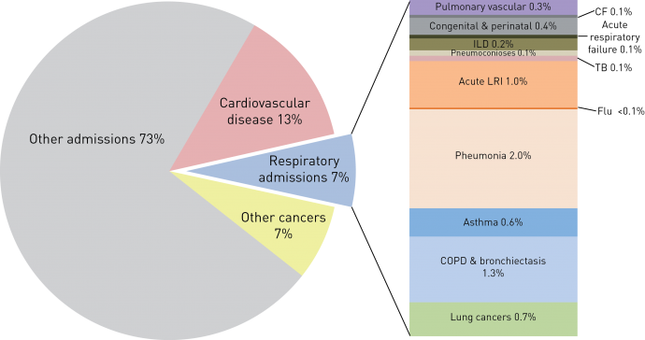

# MACRO INDUSTRY

## Competitor Analysis

It is mandatory to define who could be our competitors. There are two categories of our competitors direct and indirect competitors.

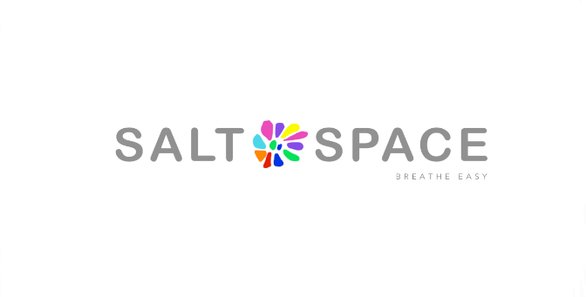

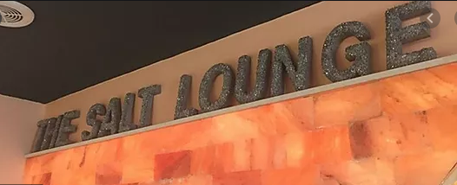

|  |  |  |  |
| --- | --- | --- | --- |
|  | **Halo Salt Therapy** | **Salt space Ltd.** | **Salt Lounge** |
| **Product** | Application of dry sodium chloride aerosol is the basic nature of Halo salt therapy.  Magic behind the Salt therapy is that they use the Himalayan salt in their treatment. | It does this by dispersing dry salt in high concentrations into a salt room whose surfaces are also layered with salt. | Salt therapy with the use of Himalayan salt. |
| **Price** | Adult: 40 pounds  Kid: 10 pounds  Private room: 50 pounds for one person | Adult: 35 pounds  Kid: 24 pounds  Private room: 45 pounds | Adult: 50 pounds  Private room: 60 pounds |
| **Place** | Golden Lane estate London | 372-374 Portland Rd Hove, England BN3 5SD United Kingdom | 853 Atlantic Ave.  Suite #102  Long Beach, CA 90813 |
| **Promotion** | TV advertising  Broachers  Posters  Celebrity endorsement | TV advertising  Broachers | TV advertising  Broachers  Celebrity endorsement |

# MICRO INDUSTRY

## Process of supplier

In the current context, each company and business idea want to demonstrate the principle of economic sustainability needs to analyze and make the process that is convenient within its operations. It focuses on the significance practices and leaves the wasteful behind that can bring the efficiency and effectiveness of the business. In order to show the operations of the HST, it is important to break further down into subsequent parts- and make the best case of easiness. As the lean methods have been successful in helping the organizations to accomplish the sustainability and prosperity, the popular framework Input-Process-Output (IPO) is useful for HST.



The input refers to all collaborations that HST will conduct with local farmers and suppliers. There is 714 suppliers in the USA. Which we can get their input in our processes.

Speaking of the process, HST aims to build the connection between the customer and from the suppliers and build the “circular economy” model that could satisfy the startup's ambition for future expansions.

As the result of the above, on the output we receive strong-value propositions to customers, allowing to formulate the critical success factors (CSFs) that would differentiate the core offering of HST from its principal competitors.

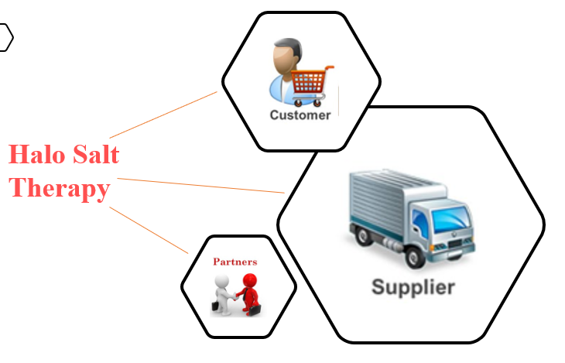

# FINANCIAL ANALYSIS

## Cash Flow Analysis

For the realization of the cash flow bring the resources we can use in a very business idea. As the expense almost spent ($750), getting the lawful license costs up to $1500. For the advertisement cost $10,000 & for the advice of business is up to $5000.

For the safety of the labor up to $30800 & payroll software can take almost $3000. As per maintaining the salt room could take $180000 & for the renovate the offices up to $50,000.

The stationary cost can be up to $1000 expense & for the utility bills $ 3500. For the initial bills of 3 months $ 40,000 & fire up the stock the cost is $15000.

The expense for securing Original SALT Booth® comes completely gathered, Halo generator, Cleaning, and Maintenance Kit, One 10-lb. the compartment of Halo-Salt and supply – $200,000  & For the acquisition of furniture and devices like computers, sound systems, chairs, tables, telephone, etc.) there is an expense of $4,000. For propelling a site there is an expense of $600 & for the Miscellaneous – $5,000

# RECOMMENDATION AND REFLECTION

This study tells us about the idea, how feasible the is, but the further eye much be needed. Although, both types of research (primary, secondary) speak that there are some services growing in the market. The intensity of the headache grows, so should the rooms for slat therapy with it and no other player in the market giving the market the same functionalities and services as we are giving to them.

This helps the entrepreneur the precautions, how they could launch this business idea. However, it is the pre-measure they need to take whether this business could run in the long run or not. There might be some other strategies to see and take the precautions in advance, but this is also one of the best that could count in the account.

# APPENDIX

## PEST Analysis and Cash Flow

After getting sight of the specific groups of the people in “Halo salt therapy”. We need to see the PESTLE analysis for this idea to establish the external factors that can bring some advantages to the inside decision that is made by the employees.

**Political**

As there is “Halo Salt therapy (HST)” is about to become the organization and they need to maintain the set some standards of laws set out by the government. There is some competitive price to decide on HST in advance to get rid of future problems. The political scenario matters beautifully due to some inflation or deflation in the market. More importantly, there is some border where HST needs to be inside the boundary which could be set by the government/politically.

**Economic**

The USA is still largely a cash-based, informal economy. The economy of the USA is 5th largest in terms of nominal gross domestic product and the USA has a population of over 207 million (the world's 5th-largest), giving it a nominal GDP per capita of $1,629. People spend quality of money for their salt therapy. So, spending money on hiring our services which saves time, money traveling from different places to find a suitable one.





**Social**

Science fiction is often a leading indicator of innovation. Where HST comes at utilizing the social gathering with our customers. Entering in the new era, HST helps to synchronize them with this new trend in the USA. Where social impact could support its services to boost it's at the highest level. Every new trend make society civilized.



**Technological**

With the newly taken birth of the new technology, companies have completely merged themselves with the most recent changes that took taken place. To mention the trend of HST where it can contribute to the technological world to create a digitize atmosphere.

**Legal**

There can be various implications upon the salt therapy. It must be known to them about the HST and services which they could pass this business easily without taking any action in ahead of the time.

## Cash Flow Statement



# REFERENCES

Brandt, S.D., Freeman, S., Sumnall, H.R., Measham, F. and Cole, J., 2011. Analysis of NRG ‘legal highs’ in the UK: identification and formation of novel cathinones. *Drug testing and analysis*, *3*(9), pp.569-575.

Calin, M.R., Calin, M.A., Radulescu, I., Simionca, I. and Mera, O., 2014. Radiometric measurements and evaluation of Radon concentration in some Northern Romanian salt mines for speleo-therapeutic, medical purposes and balneary tourism. *Acta Balneologica*, *56*, p.3.

Editorial staff, (2016). Promising or Placebo? Halo Salt Therapy: Resurgence of a salt cave spa treatment. [online]. Available from: <https://www.lung.org/about-us/blog/2016/06/promising-placebo-salt-halotherapy.html> [Accessed 20 March 2020].

Essay Sause, (2019). Health Spa PESTLE analysis. [online]. Available at: <https://www.essaysauce.com/business-essays/health-spa-pestle-analysis/> [Accessed 26 March 2020].

Poxon, C., (2018). The ultimate guide to salt therapy benefits (updated). [online]. Available from: <https://www.uk-saunas.co.uk/wp/index.php/2018/07/15/ultimate-guide-to-salt-therapy-benefits/> [Accessed 26 March 2020].

Profitable venture, (2020). How to write a Salt room business plan. [online]. Available from: <https://www.profitableventure.com/salt-room-business-plan/> [Accessed 26 March 2020].

Salt space ltd, (2020). Salt Space Ltd. Website. [online]. Available from: <https://saltspace.co.uk/> [Accessed 26 March 2020].

Salt Lounge, (2020). The Salt Lounge Wellness and good vibes. [online]. Available from: <https://www.thesaltloungelb.com/> [Accessed 26 March 2020].

Salt space association, (2020). Salt therapy as a Business. [online]. Available from: <https://www.salttherapyassociation.org/salt-therapy-as-a-business> [Accessed 26 March 2020].

Salt chamber, (2020). Halotherapy: Why dry salt therapy? [online]. Available at: <https://www.saltchamberinc.com/salt-therapy-halotherapy/> [Accessed 26 March 2020].

Shivanand, P. and Mugeraya, G., (2011). Halophilic bacteria and their compatible solutes–osmoregulation and potential applications. *Current science*, pp.1516-1521.

Shillcutt, S.D., LeFevre, A.E., Walker, C.L.F., Black, R.E. and Mazumder, S., 2014. Protocol for the economic evaluation of the diarrhea alleviation through zinc and oral rehydration salt therapy at scale through private and public providers in rural Gujarat and Uttar Pradesh, India. *Implementation Science*, *9*(1), p.164.

STA admin, (2019). 2019 trends of the salt therapy industry. [online]. Available from: <https://www.salttherapyassociation.org/blog/2019-trends-for-the-salt-therapy-industry-62> [Accessed 20 March 2020].

Tyrer, M., 2013. Salt in the UK. *European Geologist European Geologist*, p.45.

Weinreich, U.M., Nilsson, T., Mylund, L., Christiansen, H.T. and Laursen, B.S., 2014. Salt halo therapy and saline inhalation administered to patients with chronic obstructive pulmonary disease: A pilot study. *J Palliat Care Med*, *4*(185), p.2.